WEEK 6
- ReactJS

App.js
import React from 'react';

function App() {
return (
<div>
<h1>Welcome to the first session of React</h1>
</div>
);
}

export default App;

Output:

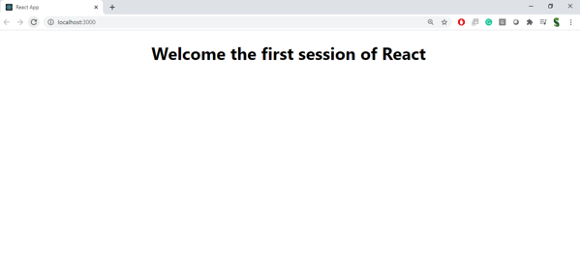
- ReactJS

Home.js
import React from 'react';
class Home extends React.Component {
render() {
return <h2>Welcome to the Home page of Student Management Portal</h2>;
}
}
export default Home;

About.js
import React from 'react';

class About extends React.Component {
render() {
return <h2>Welcome to the About page of Student Management Portal</h2>;
}
}

export default About;

Contact.js
import React from 'react';

class Contact extends React.Component {
render() {
return <h2>Welcome to the Contact page of Student Management Portal</h2>;
}
}

export default Contact;

App.js
import React from 'react';
import Home from './Components/Home';
import About from './Components/About';
import Contact from './Components/Contact';

function App() {
return (
<div>
<Home />
<About />
<Contact />
</div>
);
}

export default App;

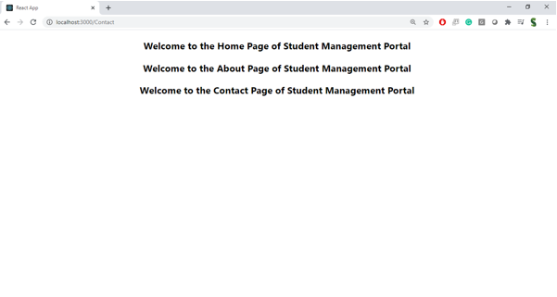
- ReactJS

Style.css
.container {
background-color: #f2f2f2;
padding: 20px;
border-radius: 10px;
}

h2 {
color: darkblue;
}

CalculateScore.js
import React from 'react';
import '../Stylesheets/style.css';

function CalculateScore(props) {
const name = 'Rithi';
const school = 'Sathyabama University';
const total = 450;
const goal = 500;
const average = (total / goal) * 100;

return (
<div className="container">
<h2>Student Score Details</h2>
<p><strong>Name:</strong> {name}</p>
<p><strong>School:</strong> {school}</p>
<p><strong>Total:</strong> {total}</p>
<p><strong>Goal:</strong> {goal}</p>
<p><strong>Average Score:</strong> {average.toFixed(2)}%</p>
</div>
);
}

export default CalculateScore;

App.js
import React from 'react';
import CalculateScore from './Components/CalculateScore';

function App() {
return (
<div>
<CalculateScore />
</div>
);
}

export default App;

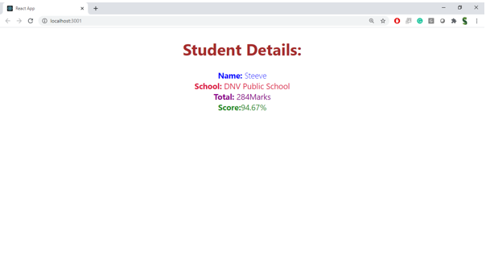
- ReactJS

Posts.js
import React, { Component } from 'react';

class Posts extends Component {
constructor(props) {
super(props);
this.state = {
posts: [],
error: null
};
}

componentDidMount() {
this.loadPosts();
}

loadPosts = () => {
fetch('https://jsonplaceholder.typicode.com/posts')
.then(res => res.json())
.then(data => this.setState({ posts: data }))
.catch(err => this.setState({ error: err.message }));
}

componentDidCatch(error, info) {
alert("An error occurred: " + error);
}

render() {
const { posts, error } = this.state;
return (
<div>
<h2>Post List</h2>
{error && <p>Error: {error}</p>}
{posts.map(post => (
<div key={post.id}>
<h3>{post.title}</h3>
<p>{post.body}</p>
</div>
))}
</div>
);
}
}

export default Posts;

App.js
import React from 'react';
import Posts from './Posts';

function App() {
return (
<div>
<Posts />
</div>
);
}

export default App;

- ReactJS

CohortDetails.module.css
.box {
width: 300px;
display: inline-block;
margin: 10px;
padding: 10px 20px;
border: 1px solid black;
border-radius: 10px;
}

dt {
font-weight: 500;
}

CohortDetails.js
import React from 'react';
import styles from './CohortDetails.module.css';

function CohortDetails({ name, status }) {
const titleStyle = {
color: status === 'ongoing' ? 'green' : 'blue'
};

return (
<div className={styles.box}>
<h3 style={titleStyle}>{name}</h3>
<dl>
<dt>Status:</dt>
<dd>{status}</dd>
</dl>
</div>
);
}

export default CohortDetails;

App.js
import React from 'react';
import CohortDetails from './CohortDetails';

function App() {
return (
<div>
<CohortDetails name="React Bootcamp" status="ongoing" />
<CohortDetails name="Java Basics" status="completed" />
</div>
);
}

export default App;

